# System Implementation & Test

## Introduction

### Overview

### Test Approach

## Database Relationship Diagram

### Physical Diagram

### Data Dictionary

## Performance Measures

### Web application page load speed

#### Definition

This section tests the general page load speed from all the page of the web application.

#### Test environment

**Server:**

* **Operating system:** Ubuntu 14.04 Server 32 bit
* **RAM:** 512 MB
* **Storage:** 20 GB
* **Processor:** 2.6 GHz Intel Core i5
* **Network:** 1 Mbps

#### Test cases

Using browser from client side and go to each page of the web application. Record the page load time using Chrome Dev Tools at client side.

**Test pages:**

* Home
* Register
* Login
* Staff / dashboard
* Staff / list contract
* Staff / detail contract
* Staff / compensation
* Staff / punishment
* Staff / accident
* Staff / card
* Staff / customer
* Customer / dashboard
* Customer / list contract
* Customer / detail contract
* Customer / compensation
* Customer / punishment
* Customer /accident
* Customer / card

#### Test result

The test is run 10 times, each time we go through all the pages listed above and log down the average page load time.

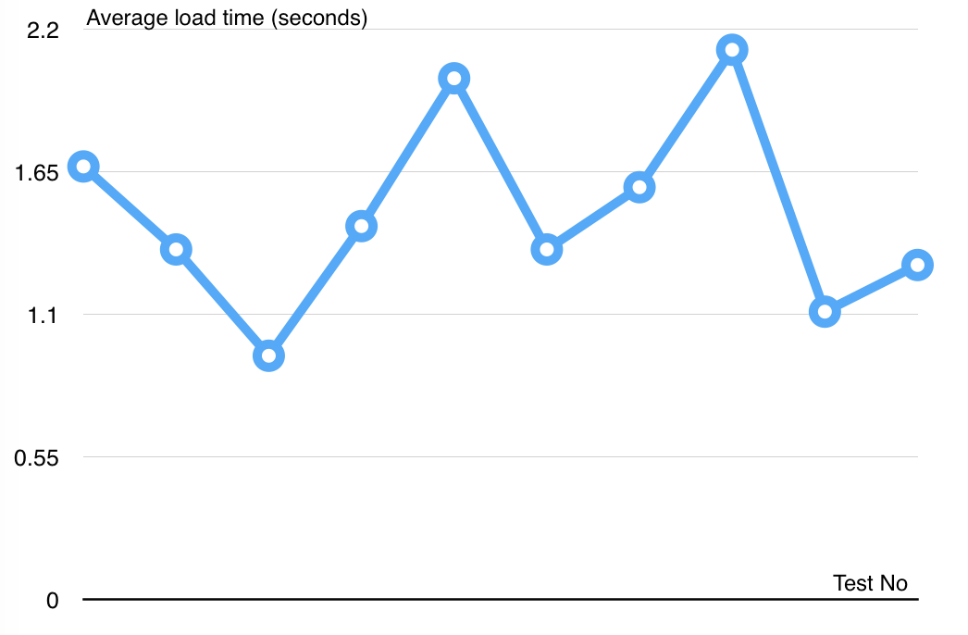

Figure Web application page load speed test result

|  |  |  |
| --- | --- | --- |
| Test No. | Average page load time (second) | Execute date |
| 1 | 1.67 | 6 July 2015 |
| 2 | 1.35 | 6 July 2015 |
| 3 | 0.94 | 6 July 2015 |
| 4 | 1.44 | 6 July 2015 |
| 5 | 2.01 | 6 July 2015 |
| 6 | 1.35 | 6 July 2015 |
| 7 | 1.59 | 6 July 2015 |
| 8 | 2.12 | 6 July 2015 |
| 9 | 1.11 | 6 July 2015 |
| 10 | 1.29 | 6 July 2015 |
|  | **Average: 1.49 (seconds)** |  |

Table Web application page load speed test result

### Mobile application load speed

#### Definition

This section tests the load speed of mobile apps when connection to server through API.

#### Test environment

**Server:**

* **Operating system:** Ubuntu 14.04 Server 32 bit
* **RAM:** 512 MB
* **Storage:** 20 GB
* **Processor:** 2.6 GHz Intel Core i5
* **Network:** 1 Mbps

**Client:**

* **Operating system:** Android 4.0
* **RAM:** 1GB

#### Test cases

Using mobile application to send all the API request to web server.

List of APIs:

|  |  |  |
| --- | --- | --- |
| No. | API | Description |
| 1 | getCheckConnection | Check server status |
| 2 | getContracts | Get contract information |
| 3 | getUpdateCardID | Update Card ID for contract |
| 4 | getCheckCard | Check card validation |
| 5 | getUpdatePunishment | Update punishment information for contract |

#### Test result

The test is run 10 times, each time we run all the test cases listed above and log down the average API response time.

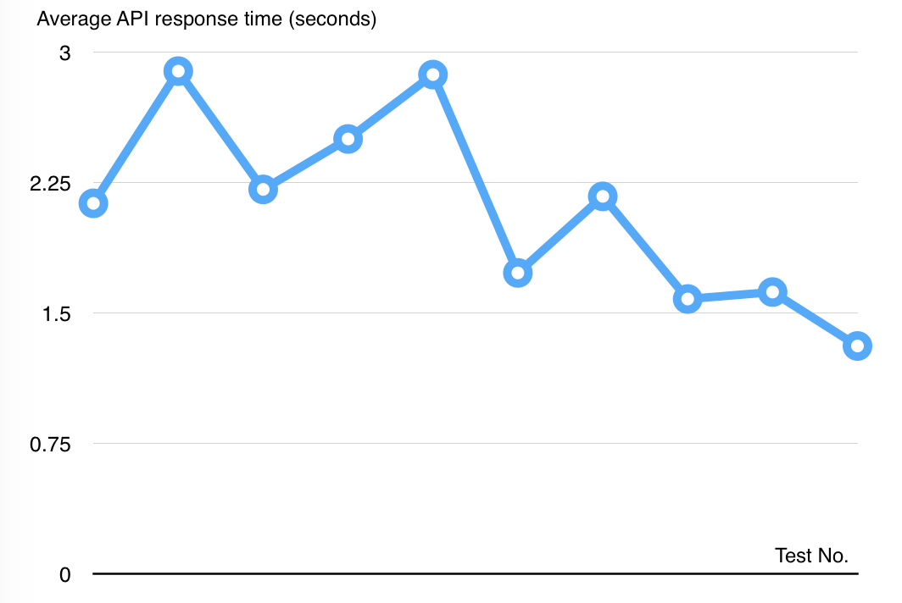

Figure Mobile application API load speed test result

|  |  |  |
| --- | --- | --- |
| Test No. | Average page load time (second) | Execute date |
| 1 | 2.13 | 6 July 2015 |
| 2 | 2.89 | 6 July 2015 |
| 3 | 2.21 | 6 July 2015 |
| 4 | 2.5 | 6 July 2015 |
| 5 | 2.87 | 6 July 2015 |
| 6 | 1.73 | 6 July 2015 |
| 7 | 2.17 | 6 July 2015 |
| 8 | 1.58 | 6 July 2015 |
| 9 | 1.62 | 6 July 2015 |
| 10 | 1.31 | 6 July 2015 |
|  | **Average: 2.10 (seconds)** |  |

Table Mobile application API load speed test result

## Test Plan

### Features to be tested

### Features not to be tested